Feature request: Pressing enter triggers a search

**January 30th 2018**

# **OBJECTIVE**

Give the ability to the user to trigger search intuitively by pressing the Enter key when ready with the search input.

# **BACKGROUND**

To trigger the page default action on Enter key press is one of the must-have features for every form. Actually users instinctively press Enter when ready with their input, no matter what type of form they are filling - a login, a registration, or just sending message in a chat application. And for a search form it’s of a high importance. Since Google enabled users to trigger Google search with the Enter key, the consumers are used to having this ability in any other search form and irritated when it’s missing.

Triggering the page default action on Enter key press is part of implementing keyboard support, a support that each professional application should have. Keyboard support is important both for the pro users who prefer using their keyboard instead of the mouse and for enabling the screen readers to work for people with disabilities.

In the case of the Jammming application, users will press the Enter key when ready with typing their search term. As a result of this action, they should have their search results populated the same way they would have if they pressed the Search button.

# **TECHNICAL DESIGN**

To trigger search when Enter key is pressed on user input we need to implement the following steps:

* Create a *handleEnter(e)* method in the *SearchBar.js* component. This method should check if the pressed is Enter, and if so, call the *search()* method of the *SearchBar.js* component. The method could look like this:

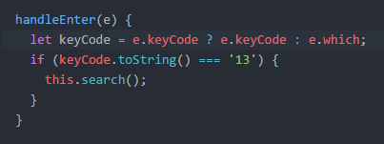

* Attach the *handleEnter(e)* method to the *onKeyPress* event of the search input. The example input declaration:

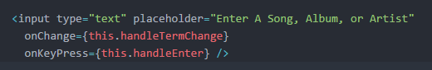

* Bind the *handleEnter(e)* method to *this* in the *SearchBar.js* component constructor as follows:



# **CAVEATS**

Handling the KeyPress event on an HTML input element might require different approach for the different browsers, especially for the older/ancient browser versions. So using this approach might end up with browser compatibility issue.

Another approach to implement the “Trigger search on Enter key press” feature are to wrap the search input and button in a <form> element. The form default action should be set to call the the search functionality.